Vaders, Vaders everywhere,  and not a drop to drink!  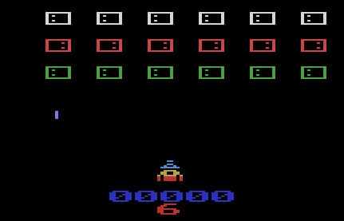  Gray Games & Snailsoftware (c) 2015  Cartridge made by Hozer Video Games  www.hozervideo.com | 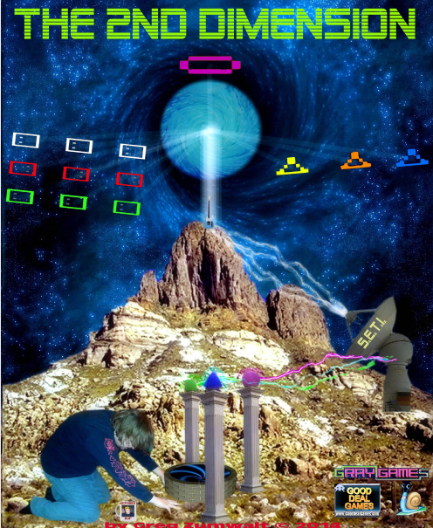
Vaders, Vaders everywhere,
and not a drop to drink!

Gray Games & Snailsoftware (c) 2015

Cartridge made by Hozer Video Games
www.hozervideo.com
The Story!    Todd wants to go back in time by any means possible to attend a Black Sabbath Concert in the 1970's. Todd acquired some rare earth crystals from a witch on Whyte Avenue and some S.E.T.I. technology he found disposed of behind his apartment building.  Todd journeyed to mountain in the south to open what he thought would be a time portal. Little did Todd know that in fact the portal would open up a gateway not to the past, but to the 2nd Dimension. You are Todd and with your ahem found laser rifle have entered the 2nd Dimension. There you must do battle with various flying 2nd Dimensional Entities to save Earth from this most hostile invader. | The Back Story!  Back in 1995, I Greg Zumwalt, Cavina, Mooney, Robert Colbert, and others, decided to try and come up with a new invaders style clone. We each based our code on an existing game and proceeded. Colbert beat everyone to the punchline and the other projects faded away.  I never explained why I never released this code until now. Through this game can I finally show you all where I slipped through a crack in dimensions and found myself in the 2nd Dimension. I had to fight for my life while there, Todd then helped me escape, and now I can show you inside the 2nd Dimension.
The Story!  Todd wants to go back in time by any means possible to attend a Black Sabbath Concert in the 1970's. Todd acquired some rare earth crystals from a witch on Whyte Avenue and some S.E.T.I. technology he found disposed of behind his apartment building.  Todd journeyed to mountain in the south to open what he thought would be a time portal. Little did Todd know that in fact the portal would open up a gateway not to the past, but to the 2nd Dimension. You are Todd and with your ahem found laser rifle have entered the 2nd Dimension. There you must do battle with various flying 2nd Dimensional Entities to save Earth from this most hostile invader. | The Back Story!  Back in 1995, I Greg Zumwalt, Cavina, Mooney, Robert Colbert, and others, decided to try and come up with a new invaders style clone. We each based our code on an existing game and proceeded. Colbert beat everyone to the punchline and the other projects faded away.  I never explained why I never released this code until now. Through this game can I finally show you all where I slipped through a crack in dimensions and found myself in the 2nd Dimension. I had to fight for my life while there, Todd then helped me escape, and now I can show you inside the 2nd Dimension.

